

Anjuman-I-Islam’s

**M. H. SABOO SIDDIK POLYTECHNIC**

A Micro Project Report on:

________________________________________

Submitted by:

|  |  |  |
| --- | --- | --- |
| SR.NO | ROLL NO | NAME OF THE STUDENTS |
| 1 | 210422 | Abdullah Baghdadi |
| 2 | 210451 | Abdurrahman Qureshi |
|  |  |  |

Guided By:

**Ms. Zaibunnisa Malik**

For the Subject:

**OBJECT ORIENTED PROGRAMMING**

In Academic Year

2022-2023



**MAHARASHTRA STATE**

**BOARD OF TECHNICAL EDUCATION**

**CERTIFICATE**

This is to certify that Mr**. Abdullah Baghdadi** Roll No. **210422,** of Fourth Semester of Diploma in **COMPUTER ENGINEERING** of Institute **M. H. SABOO SIDDIK POLYTECHNIC (**Code: 0002) has completed the term work satisfactorily in course JAVA (22412) for the academic year **2022** to **2023** as prescribed in the curriculum.

Place: Enrollment No:

Date: Exam. Seat No:

Subject Teacher Head of the Department Principal



**MAHARASHTRA STATE**

**BOARD OF TECHNICAL EDUCATION**

**Certificate**

This is to certify that Mr**. Abdurrahman Qureshi** Roll No. **210451,** of Fourth Semester of Diploma in **COMPUTER ENGINEERING** of Institute **M. H. SABOO SIDDIK POLYTECHNIC (**Code: 0002) has completed the term work satisfactorily in course JAVA (22412) for the academic year **2022** to **2023** as prescribed in the curriculum.

Place: Enrollment No:

Date: Exam. Seat No:

Subject Teacher Head of the Department Principal

**ACKNOWLEDGMENT**

This micro project is done as a course project, as a part course titled

**“OBJECT ORIENTED PROGRAMMING**”

We are really thankful to our Course teacher **Ms. Zaibunnisa Malik** for his invaluable guidance and assistance, without which the accomplishment of the task would have never been possible We also thank our **Principal Dr. A. K. Kureshi , and HOD** for giving the opportunity to explore into the real world and realize the interrelation without which a Project can never progress. In our present project we have chosen the topic-

**“DIGITAL PIANO”**

We are also thankful to parents, friend and all staff of Computer Engineering Department, for providing us relevant information and necessary clarifications, and great support.



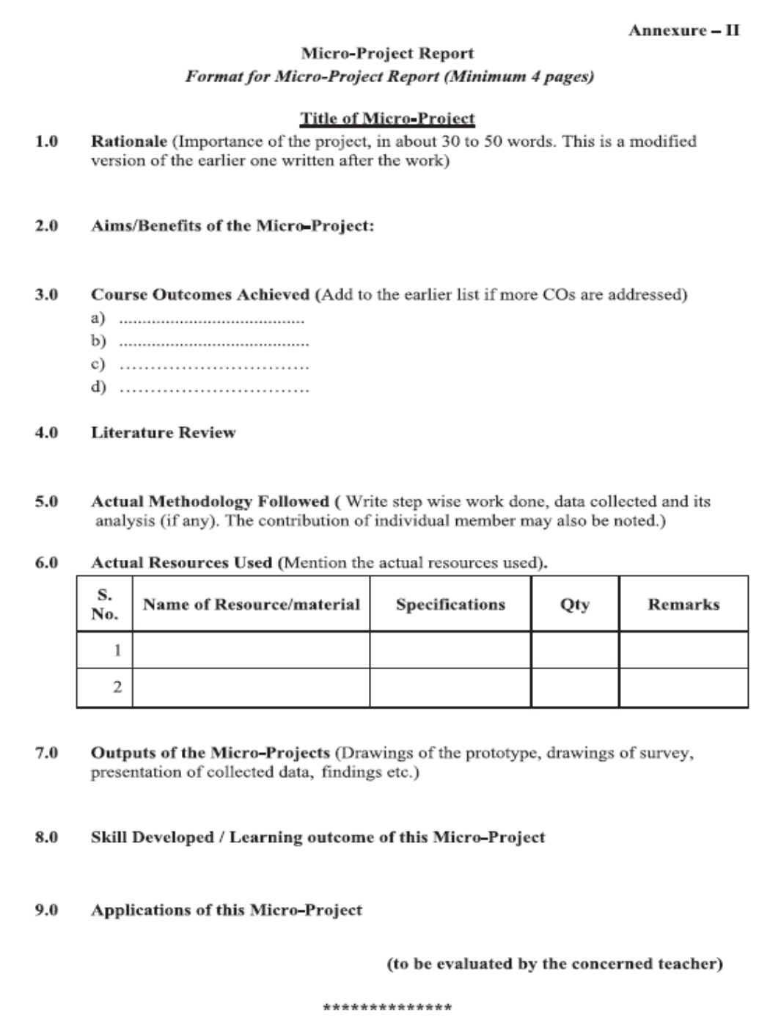

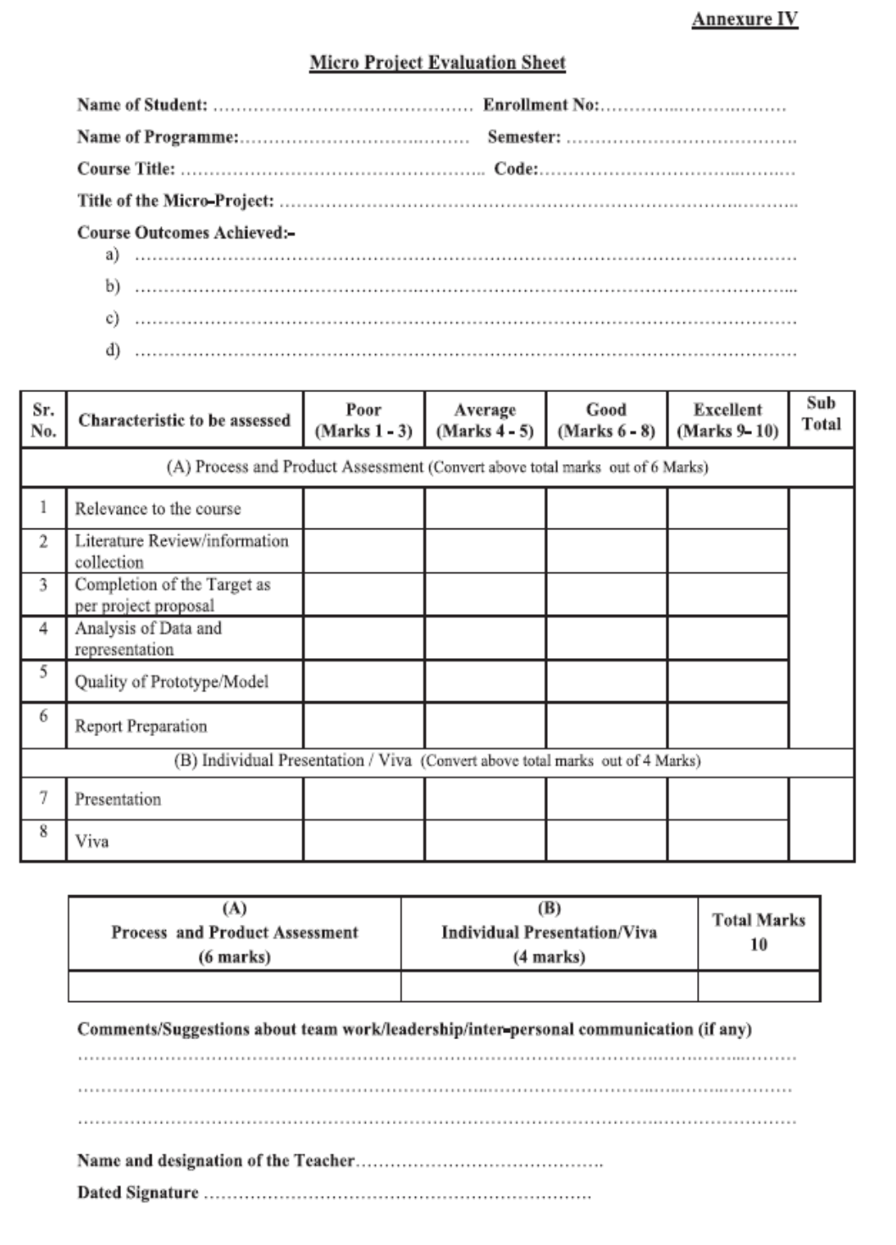



**Student name:** Abdurrahman Qureshi

**Roll no:**210451

Day: 1 Duration: 2 HR

Today, we were informed to form groups of three students for the OOP micro-project, we were required to create an enhancive microproject and ma’am specified that the group strength should not exceed more than three students. And told us to search the micro-project topic, the topic should be industry application based, internet-based, workshop-based, laboratory-based or field-based. And told that the micro-project should encompass two or more Cos which are in fact, an integration of PrOs, UOs, and ADOs. He also told the each group member will have to maintain a dated diary consisting of individual contribution in the project work. The total duration of the micro-project should not be less than 16 student engagement hours during the course. And the micro-project should be submitted before the end of the semester to develop the industry oriented Cos.

Following are my team-members:

* 1. Abdurrahman Qureshi (210451)
  2. Abdullah Baghdai(210422)

Day: 2 Duration: 2 HR

Today, we started searching the micro-project topic on the internet. We found many topics like College Management System, Hotel Billing System, Medical Store stock management system etc. We decided to work on **DIGITAL PIANO**. Ma’am explained to us the packages and classes to be made, the concept of various inheritance that should be considered and begin the work on micro-project. We started discussing the topics to be covered that has to be done to make the project complete. We decided to divide the work between us and work individually to make the project.

Day: 3 Duration: 2 HR

We were supposed to design the overall structure of the project and we were working on the actual code that has to be implemented. We decided to make different classes and using different keywords like super final in the classes.

Day: 4 Duration: 2 HR

Today, we decided to implement classes. We decided to use user defined exception, etc.

Day: 5 Duration: 2 HR

As we decided to make a different classes and packages such as login, student class, exam class so it became easy for us to divide the work. 1. **Abdurrahman** was implementing the user defined exception class was designing user defined package which will we further imported 3. **Abdullah** was implementing switch case and the final result class. And we decided to complete it on Day 6 and explain the code to everyone one. We started searching the best possible way that can be implemented.

Day: 6 Duration: 2 HR

I finally completed my work and explained the form to my fellow members. We compiled and interpreted the code .The code was error-free we got the output on our first attempt to run it. Now, the final work was to create a report on the micro-project which we decided to make on Day 7.

Day: 7 Duration: 2 HR

Ma’am instructed us the format of the report and according to it we started creating the report. Ma’am told us to submit the report on 22-03-2020. The report was completed and we took the hard copy of it.

Day: 8 Duration: 2 HR

We submitted the report. Creating such projects boosts our Communication skills, debugging skills. It also gives us an experience of how to work in a team.

**Student name:** Abdurrahman Qureshi

**Student name:** Abdullah Baghdadi

**Roll no:**210422

Day: 1 Duration: 2 HR

Today, we were informed to form groups of three students for the OOP micro-project, we were required to create an enhancive microproject and ma’am specified that the group strength should not exceed more than three students. And told us to search the micro-project topic, the topic should be industry application based, internet-based, workshop-based, laboratory-based or field-based. And told that the micro-project should encompass two or more Cos which are in fact, an integration of PrOs, UOs, and ADOs. He also told the each group member will have to maintain a dated diary consisting of individual contribution in the project work. The total duration of the micro-project should not be less than 16 student engagement hours during the course. And the micro-project should be submitted before the end of the semester to develop the industry oriented Cos.

Following are my team-members:

* 1. Abdurrahman Qureshi (210451)
  2. Abdullah Baghdai(210422)

Day: 2 Duration: 2 HR

Today, we started searching the micro-project topic on the internet. We found many topics like College Management System, Hotel Billing System, Medical Store stock management system etc. We decided to work on **DIGITAL PIANO**. Ma’am explained to us the packages and classes to be made, the concept of various inheritance that should be considered and begin the work on micro-project. We started discussing the topics to be covered that has to be done to make the project complete. We decided to divide the work between us and work individually to make the project.

Day: 3 Duration: 2 HR

We were supposed to design the overall structure of the project and we were working on the actual code that has to be implemented. We decided to make different classes and using different keywords like super final in the classes.

Day: 4 Duration: 2 HR

Today, we decided to implement classes. We decided to use user defined exception, etc.

Day: 5 Duration: 2 HR

As we decided to make a different classes and packages such as login, student class, exam class so it became easy for us to divide the work. 1. **Abdurrahman** was implementing the user defined exception class was designing user defined package which will we further imported 3. **Abdullah** was implementing switch case and the final result class. And we decided to complete it on Day 6 and explain the code to everyone one. We started searching the best possible way that can be implemented.

Day: 6 Duration: 2 HR

I finally completed my work and explained the form to my fellow members. We compiled and interpreted the code .The code was error-free we got the output on our first attempt to run it. Now, the final work was to create a report on the micro-project which we decided to make on Day 7.

Day: 7 Duration: 2 HR

Ma’am instructed us the format of the report and according to it we started creating the report. Ma’am told us to submit the report on 22-03-2020. The report was completed and we took the hard copy of it.

Day: 8 Duration: 2 HR

We submitted the report. Creating such projects boosts our Communication skills, debugging skills. It also gives us an experience of how to work in a team.

**Student name:** Abdullah Baghdadi

/*-------------------------------------------------------------------------------*/

// Header Files

/*-------------------------------------------------------------------------------*/

#include <iostream>

#include <conio.h>

#include <windows.h>

#include "MMSystem.h"

#include <graphics.h>

#include <dos.h>

using namespace std;

/*-------------------------------------------------------------------------------*/

// GLOBAL DECLARATIONS

/*-------------------------------------------------------------------------------*/

int i;

/*-------------------------------------------------------------------------------*/

// Loading Function

/*-------------------------------------------------------------------------------*/

void loadingScreen()

{

// Loading Text

setcolor(15);

settextstyle(0, 0, 3);

rectangle(50, 20, 530, 160);

outtextxy(90, 70, "Your Piano");

outtextxy(120, 100, "is Processing!!!");

settextstyle(0, 0, 1);

outtextxy(542, 40, " * Sorry,");

outtextxy(542, 55, " we have");

outtextxy(542, 70, " only two");

outtextxy(542, 85, " GigaBytes");

outtextxy(542, 100, " of RAM ");

outtextxy(542, 115, " in this");

outtextxy(542, 130, " computer *");

settextstyle(0, 0, 2);

outtextxy(40, 250, " Get ready to play the P-I-A-N-O!!!");

outtextxy(100, 350, "Loading...");

rectangle(99, 379, 549, 391);

for (int i = 0; i < 448; i++)

{

setcolor(15);

rectangle(100 + i, 380, 548, 390);

delay(10);

}

setcolor(15);

settextstyle(0, 0, 1);

outtextxy(400, 430, "Press any key to continue...");

getch();

}

/*-------------------------------------------------------------------------------*/

// Home Screen Function

/*-------------------------------------------------------------------------------*/

void homeScreen()

{

setcolor(15);

line(0, 196, 640, 196);

line(0, 197, 640, 197);

line(0, 198, 640, 198);

line(0, 199, 640, 199);

line(0, 200, 640, 200);

line(0, 201, 640, 201);

line(0, 202, 640, 202);

line(0, 203, 640, 203);

line(0, 204, 640, 204);

settextstyle(0, 0, 4);

outtextxy(250, 100, "OOP"); // Title

outtextxy(50, 160, " Micro-Project"); // Title

settextstyle(0, 0, 2);

outtextxy(120, 250, "Guided By Ms. Zeba"); // Faculty

settextstyle(0, 0, 1);

outtextxy(120, 320, "210422"); // Participants Roll No

outtextxy(120, 300, "210451"); // Participants Roll No

}

/*-------------------------------------------------------------------------------*/

// Class Main

/*-------------------------------------------------------------------------------*/

class MAIN

{

private:

int stx, sty, enx, eny, stx1 = 70, sty1 = 130;

public:

// char sounds[18][5]={"a.wav","b.wav","c.wav","d.wav","e.wav","f.wav","g.wav","h.wav","i.wav","j.wav","k.wav","l.wav","m.wav","n.wav","o.wav","p.wav","q.wav","r.wav"};

// char path[5];

void completekey(int stx, int sty, int decision)

{

line(stx + 30, sty, stx + 30, sty + 200); // second key border

line(stx + 60, sty + 101, stx + 60, sty + 200); // third key border

setcolor(8);

setcolor(WHITE);

rectangle(stx + 50, sty + 1, stx + 70, sty + 100); // mid small key2

setfillstyle(SOLID_FILL, 8);

floodfill(stx + 51, sty + 99, WHITE);

setcolor(WHITE);

line(stx + 90, sty, stx + 90, sty + 200); // third key border

stx = stx + 30;

}

void operations(int stx1, int sty1)

{

setfillstyle(SOLID_FILL, 7);

floodfill(stx1 + 1, sty1 - 1, WHITE);

delay(150);

setfillstyle(SOLID_FILL, BLACK);

floodfill(stx1 + 1, sty1 - 1, WHITE);

}

/*-------------------------------------------------------------------------------*/

// Input Function

/*-------------------------------------------------------------------------------*/

void getdata(int stx, int sty)

{

cout << "\nEnter a key/or multiple keys\n ";

cout << "\nPress 'Y' to exit\n\n";

char ch, t = 'Y';

while (1)

{

ch = getch();

if (ch == 'Y')

{

cout << "Exit Complete";

break;

}

stx1 = stx - 17;

sty1 = sty + 180;

switch (ch)

{

case 'a':

operations(stx1, sty1);

PlaySound("a.wav", NULL, SND_FILENAME);

break;

case 'b':

stx1 = stx1 + 17;

sty1 = sty1 - 1;

operations(stx1, sty1);

PlaySound("b.wav", NULL, SND_FILENAME);

break;

case 'c':

stx1 = stx1 + 50;

sty1 = sty1 - 1;

operations(stx1, sty1);

PlaySound("c.wav", NULL, SND_FILENAME);

break;

case 'd':

stx1 = stx1 + 83;

sty1 = sty1 - 1;

operations(stx1, sty1);

PlaySound("d.wav", NULL, SND_FILENAME);

break;

case 'e':

stx1 = stx1 + 116;

sty1 = sty1 - 1;

operations(stx1, sty1);

PlaySound("e.wav", NULL, SND_FILENAME);

break;

case 'f':

stx1 = stx1 + 149;

sty1 = sty1 - 1;

operations(stx1, sty1);

PlaySound("f.wav", NULL, SND_FILENAME);

break;

case 'g':

stx1 = stx1 + 182;

sty1 = sty1 - 1;

operations(stx1, sty1);

PlaySound("g.wav", NULL, SND_FILENAME);

break;

case 'h':

stx1 = stx1 + 215;

sty1 = sty1 - 1;

operations(stx1, sty1);

PlaySound("h.wav", NULL, SND_FILENAME);

break;

case 'i':

stx1 = stx1 + 248;

sty1 = sty1 - 1;

operations(stx1, sty1);

PlaySound("i.wav", NULL, SND_FILENAME);

break;

case 'j':

stx1 = stx1 + 281;

sty1 = sty1 - 1;

operations(stx1, sty1);

PlaySound("j.wav", NULL, SND_FILENAME);

break;

case 'k':

stx1 = stx1 + 314;

sty1 = sty1 - 1;

operations(stx1, sty1);

PlaySound("k.wav", NULL, SND_FILENAME);

break;

case 'l':

stx1 = stx1 + 340;

sty1 = sty1 - 1;

operations(stx1, sty1);

PlaySound("l.wav", NULL, SND_FILENAME);

break;

case 'm':

stx1 = stx1 + 373;

sty1 = sty1 - 1;

operations(stx1, sty1);

PlaySound("m.wav", NULL, SND_FILENAME);

break;

case 'n':

stx1 = stx1 + 400;

sty1 = sty1 - 1;

operations(stx1, sty1);

PlaySound("n.wav", NULL, SND_FILENAME);

break;

case 'o':

stx1 = stx1 + 433;

sty1 = sty1 - 1;

operations(stx1, sty1);

PlaySound("o.wav", NULL, SND_FILENAME);

break;

case 'p':

stx1 = stx1 + 455;

sty1 = sty1 - 1;

operations(stx1, sty1);

PlaySound("p.wav", NULL, SND_FILENAME);

break;

case 'q':

stx1 = stx1 + 488;

sty1 = sty1 - 1;

operations(stx1, sty1);

PlaySound("q.wav", NULL, SND_FILENAME);

break;

case 'u':

stx1 = stx1 + 521;

sty1 = sty1 - 1;

operations(stx1, sty1);

PlaySound("r.wav", NULL, SND_FILENAME);

break;

}

}

}

/*-------------------------------------------------------------------------------*/

// Piano Function

/*-------------------------------------------------------------------------------*/

void piano(int stx, int sty, int enx, int eny)

{

int cstx = stx, csty = sty, cenx = enx, ceny = eny;

char i = 'a';

rectangle(stx, sty, enx, eny); // body

// firstkey

setcolor(WHITE);

line(stx + 30, sty + 101, stx + 30, sty + 200); // first key border

setcolor(8);

setcolor(WHITE);

rectangle(stx + 40, sty + 1, stx + 20, sty + 100); // mid small key1

setfillstyle(SOLID_FILL, 8);

floodfill(stx + 31, sty + 99, WHITE);

setcolor(WHITE);

// firstkey

stx = stx + 30;

completekey(stx, sty, 1);

completekey(stx + 60, sty, 2);

completekey(stx + 120, sty, 3);

completekey(stx + 180, sty, 4);

completekey(stx + 240, sty, 5);

completekey(stx + 300, sty, 6);

completekey(stx + 360, sty, 7);

completekey(stx + 420, sty, 8);

outtextxy(stx - 17, sty + 180, "a");

outtextxy((stx + 30) - 17, sty + 180, "b");

outtextxy((stx + 60) - 17, sty + 180, "c");

outtextxy((stx + 90) - 17, sty + 180, "d");

outtextxy((stx + 120) - 17, sty + 180, "e");

outtextxy((stx + 150) - 17, sty + 180, "f");

outtextxy((stx + 180) - 17, sty + 180, "g");

outtextxy((stx + 210) - 17, sty + 180, "h");

outtextxy((stx + 240) - 17, sty + 180, "i");

outtextxy((stx + 270) - 17, sty + 180, "j");

outtextxy((stx + 300) - 17, sty + 180, "k");

outtextxy((stx + 330) - 17, sty + 180, "l");

outtextxy((stx + 360) - 17, sty + 180, "m");

outtextxy((stx + 390) - 17, sty + 180, "n");

outtextxy((stx + 420) - 17, sty + 180, "o");

outtextxy((stx + 450) - 17, sty + 180, "p");

outtextxy((stx + 480) - 17, sty + 180, "q");

outtextxy((stx + 510) - 17, sty + 180, "u");

}

};

/*-------------------------------------------------------------------------------*/

// Main Function

/*-------------------------------------------------------------------------------*/

int main()

{

int gd = DETECT, gm;

int stx = 40, sty = 100, enx = 580, eny = 300;

initgraph(&gd, &gm, (char *)"");

for (i = 0; i < 100; i++)

{

homeScreen();

delay(5);

}

outtextxy(400, 400, "Press any key to continue...");

getch();

cleardevice();

loadingScreen();

cleardevice();

MAIN s;

s.piano(stx, sty, enx, eny);

s.getdata(71, 99);

getch();

closegraph();

return 0;

}

